# INFO 2302 Web Technologies

# Class Exercise 4

# Tables and Forms

# Table of Contents

Exercise 4.1 Creating your Class Timetable (45 minutes) 2

Exercise 4.2 Creating a Nutrition Table (20 minutes) 4

Exercise 4.3 Creating a simple Login page (45 minutes) 5

## Exercise 4.1 Creating your Class Timetable (45 minutes)

1. Open a new file and name it as timetable.html
2. Modify the given template code to create your own class timetable.
3. The sample output is shown below:

<!DOCTYPE html>

<html>

<head>

<title>Class Timetable</title>

</head>

<body>

<h1>Class Timetable</h1>

<table border="1">

<thead>

<tr>

<th>Time</th>

<th>Monday</th>

<th>Tuesday</th>

<th>Wednesday</th>

<th>Thursday</th>

<th>Friday</th>

</tr>

</thead>

<tbody>

<tr>

<td>8:00 AM</td>

<td>Web Technologies</td>

<td></td>

<td>Maths for Computing I</td>

<td></td>

<td></td>

</tr>

<tr>

<td>9:00 AM</td>

<td></td>

<td></td>

<td></td>

<td>Human Computer Interaction</td>

<td></td>

</tr>

<!-- Add more rows for other times -->

</tbody>

<tfoot>

<tr>

<td colspan="6">Note: This timetable is subject to change.</td>

</tr>

</tfoot>

</table>

</body>

</html>

## Exercise 4.2 Creating a Nutrition Table (20 minutes)

Instructions: Update your previous exercise on multi-pages website

1. Open a new file and name it as nutrition.html.
2. Use HTML to create the following Nutrition Table:

1. Insert header image and navigation bar above the nutrition table from Exercise 2.2 – Creating a multi-page website.

1. Link nutrition.html with the rest of the files in the multi-page website.

## Exercise 4.3 Creating a simple Login page (45 minutes)

Instructions: Search Internet resources to build suitable regular expressions (regex).

1. Open a new file and name it as login.html.
2. Create the following form controls:

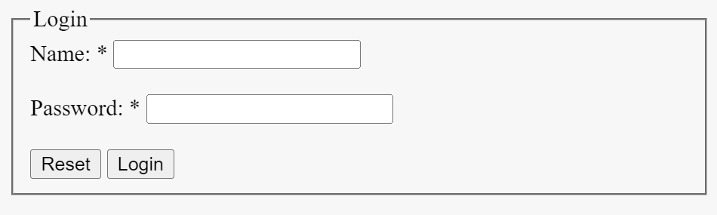

1. Using regular expression, validate the password textfield against the following rules:
   1. must contains one digit from 0-9.
   2. must contains at least one special character.
   3. length at least 8 characters and maximum of 20